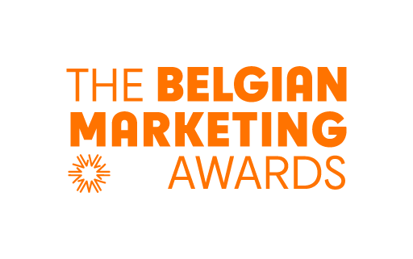

CONFIRMATION FORM

Case Entry FORM For

Marketing Company of the year

The CASE ENTRY FORM is pre-formatted document, which you should use for submitting your case. It contains 6 sections with a limited number of lines for each of the sections.

The deadline for your CASE ENTRY is August 20, 2025. Please send your Case entry Form in PDF and in English to nathalie.prieto@marketing.be.

Your coordinates:
First name:
Name:
E-mail:
Phone number:
Company:
The Title of your case:

SECTION 1 :

Introduction: The context & Challenge & Opportunities and Threats

Introduce the company: What are the activities? In which category/categories your company is operating? Who are your main competitors? Etc…:

(max. 10 lines)

Introduce your case : What is the context ? What is the issue/the challenge ? What are the risks and opportunities ?

(max. 20 lines)

SECTION 2 (20 points):

Business Strategy

What is the business strategy ? What does your company tries to achieve ? How do you measure business success ? What are the KPI’s ?

(max. 20 lines)
What are the business results ?

(max. 20 lines)

SECTION 3 : Marketing (20 points):

Marketing Strategy

Marketing Strategy : What is the marketing strategy? What kind of customers is your company targeting? How does your company build relationships with clients? How do you measure success? What are the marketing KPI’s ?

(max 20 lines)

Value proposition

Value proposition : From a customer centric perspective : Describe the customer centric value proposition ? What make this proposition unique, different from your competitors, outstanding?

(max 20 lines)

Marketing Results

Referring to the Marketing KPI’s, what are the marketing results ? (Be as metrics specific as possible, highlighting the evolution of key metrics (market share, sales, growth rate over periods over 12 months...)

(max 20 lines)

SECTION 4 : Making a positive impact on Society (20 points):
Environmental challenges (10 points)
Our society is facing environmental challenges, brands and companies can contribute to a more sustainable society for example by promoting sustainable products and services (circular, regeneration, recycling, bio, ….) or by encouraging sustainable consumption behaviors. How did your brand /company make a positive impact with respect to environmental challenges ? Which actions did you put in place to help consumers to consume/ to behave in a more sustainable way … new products, new services, more informed communication ?

(Take into account not only actions in the communication but also in the overall marketing mix. )

(max 20 lines)

Inclusion & Diversity (10 points )
How did you make a positive impact with respect to the challenges regarding Inclusion & Diversity ?

(The following elements and questions can help you answer this:
- Key actions from your D&I policy & how the policy is applied in daily operations, strategies and (marketing) campaigns
- How inclusive is your innovation portfolio to fit consumers with all backgrounds and needs?
- How do you handle feedback and make inclusive improvements?
- How do you provide support for minority communities)
Note that we are not asking for diversity statistics, but for concrete actions.

For inspiration, have you read the Belgian Ad diversity barometer ?

(max 20 lines)

SECTION 5 : Data innovation, MarTech , Ethics and Privacy (20 points):
Attention : for this section 5 a special mention of excellence will be awarded
Data Innovation & MarTech (10 points )
Today marketers have a wide choice of technological tools at their disposal to understand, connect, engage with their customers and to deliver more personalized solutions.
The toolbox of the marketer has never been so filled up with data analytics, digital marketing channels, AI and automation tools and content creation for emerging platforms, etc…

How does the toolbox of your brand/company looks like ?
And how do the data and tools contribute to more successful marketing practice ?
And how does the future roadmap looks like ?
How do you ensure that the use of AI strongly enriches the marketing strategy and is not simply used as a new gimmick ?
Do you balance its use and benefits against the impact on the environment ?

(max 20 lines)

Privacy and Ethics (10 points)
With increasing concerns about data privacy and the phasing out of third-party cookies, marketers are focusing on building and leveraging first-party data to understand their customers and personalize experiences in a privacy-compliant way.

And some are using new technologies to gather insights while respecting user privacy.

How does your brand/company cope with this ? How do you balance the benefits of the use of Marketing Technology (AI for example ) against the impact on social ethics, etc…

(max 20 lines)

SECTION 6 (20 points):
Thought leadership?
Successful Marketing : in your opinion, what is the role of marketing with respect to the growth of the company ? And how to balance between short term and long term ? How should marketers cope with ‘marketing agility’ in a fast changing world ?

(max 20 lines)

Business models are shifting towards people, planet and profit. How can marketing/the marketers become more meaningful within this new context ?

What should Marketing / the Marketers change (stop-start-continue doing) in their practice ?

(max 20 lines)

Thank you for your participation
Send this document in PDF to nathalie.prieto@marketing.be before August 20, 2025
The selection Committee will announce the finalists by September 22, 2025
Finalists will present their case to the Jury on October 13,2025
Ceremony BMA Awards on November 5, 2025

Need more information?
www.belgianmarketingawards.be
Email : nathalie.prieto@marketing.be

